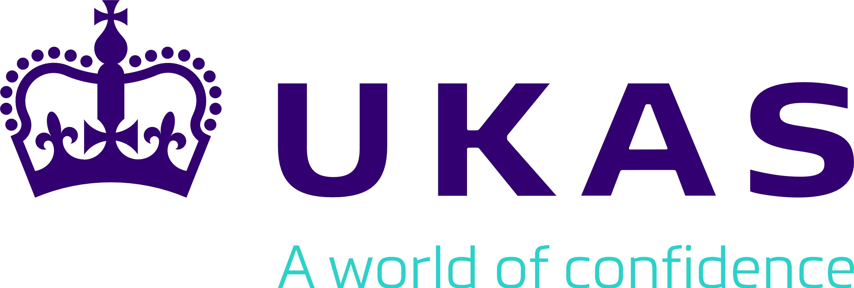

Agreement for the Use of the UKAS Accredited CAB Combined ILAC MRA Marks

1. This Agreement IS effective as of the Date signed by and between

United Kingdom Accreditation Service with registered number 03076190 (“UKAS”)

AND UKAS Accredited CAB (Conformity Assessment Body)

Note: If the CAB is an incorporated entity (such as a limited company or limited liability partnership) then the CAB name should be the name of that entity and the registered company / entity number should be used. If the CAB is unincorporated (such as a sole trader, unincorporated partnership or unincorporated trust), then the names of the individual people should be used instead.

For example

XYZ Limited OR Fred Smith and Jo Bloggs (trading as XYZ & Co)
Company number: 123456 Company Number: N/A

CAB Name: Enter accredited CAB’s full company name here

Company Number (if applicable): Enter company number here (N/A if not applicable)

UKAS Accreditation No.: Enter accreditation number here

Address: enter full business address here

Herein referred to as the accredited CAB

2. BACKGROUND

ILAC is the owner of the ILAC MRA Mark and has licensed the use of the ILAC MRA Mark to UKAS in accordance with the terms of the ILAC MRA Mark Agreement, pursuant to which UKAS has developed the UKAS Accredited CAB Combined ILAC MRA Marks.

The accredited CAB has been accredited by UKAS, pursuant to a separate agreement (the “UKAS Accreditation Agreement”). As part of its accreditation, UKAS wishes to permit the accredited CAB to use the UKAS Accredited CAB Combined ILAC MRA Mark(s), in accordance with the provisions of this agreement.

3. DEFINITIONS

- ILAC: International Laboratory Accreditation Cooperation (registered in the Netherlands at Mariaplaats 21d, 3511 LK Utrecht, the Netherlands).

- ILAC MRA Mark: the international trademark registered on 21 April 2004 with registered number 840857 in NICE class 42, of which ILAC is the registered holder.

- ILAC MRA Mark Agreement: the Agreement for the Use of the ILAC MRA Mark made between UKAS and ILAC with effect from 26 June 2015.

- Restricted Marks: means the ILAC MRA Mark and / or the UKAS Accredited CAB Combined ILAC MRA Mark.

- Rules for Use: the ILAC-R7 Rules for the Use of the ILAC MRA Mark, published by ILAC on the ILAC website (as updated periodically by ILAC).

- UKAS Accredited CAB Combined ILAC MRA Mark(s): is the ILAC MRA Mark used in combination with the UKAS accreditation symbol(s) that the accredited CAB is entitled to use.

4. GRANT

In consideration of the obligations of the accredited CAB under this agreement, UKAS grants the accredited CAB a non-exclusive licence to use the UKAS Accredited CAB Combined ILAC MRA Mark strictly in accordance with the provisions of this agreement.

5. ACCREDITED CAB’S OBLIGATIONS AND REQUIREMENTS

- The accredited CAB shall ensure it holds permission from UKAS, through this signed Agreement, before using the UKAS Accredited CAB Combined ILAC MRA Mark.

- Use of the Restricted Marks shall only be granted to an accredited CAB established in territories in which the ILAC MRA Mark is a registered trade mark (or equivalent), or where an application for registration has been lodged and registration is pending. The accredited CAB may use the Restricted Marks for activities undertaken outside the economy in which they are established.
- The accredited CAB shall ensure that, at all times, its use of the UKAS Accredited CAB Combined ILAC MRA Mark:
  - does not breach any requirements set out in the Rules for Use; and
  - will not cause UKAS to breach the terms of the MRA.

- The accredited CAB agrees to adhere to the rules for use of the UKAS Accredited CAB Combined ILAC MRA Mark at all times, this includes the provisions of this agreement, the provisions of the UKAS Accreditation Agreement and the Rules for Use.

- The UKAS Accredited CAB Combined ILAC MRA Mark shall only be reproduced in the manner prescribed in Sections 3 and 6 of the Rules for Use. The ILAC MRA Mark shall be positioned such that the UKAS symbol may be either above, below or on either side of the ILAC MRA Mark, but shall appear in close proximity to each other.

- The accredited CAB will indemnify UKAS against all liabilities, costs, expenses, damages and losses (including, but not limited to any direct, indirect or consequential losses, loss of profit, loss or reputation and all interest, penalties and legal costs, calculated on a full indemnity basis) due to the accredited CAB’s:
  - exercise of its rights under this agreement (including, but not limited to, any claim made against UKAS or ILAC for actual or alleged infringement of a third party’s intellectual property rights arising out of or in connection with the accredited CAB’s exercise of its rights); or
  - misuse of any of the Restricted Marks, including breach or negligent performance or non-performance of this agreement.

UKAS will give the accredited CAB a written notice of any intended action under this clause 5(f), to which the accredited CAB has three weeks to answer before UKAS shall be entitled to take proceedings against the accredited CAB. During this time the accredited CAB must take all reasonable steps to restore the situation to compliance with this agreement, working in close cooperation with UKAS.

- The accredited CAB will not:
  - use the ILAC MRA Mark in any form other than as part of a UKAS Accredited CAB Combined ILAC MRA Mark;
  - use in its business any other trade mark is similar to any of the Restricted Marks and could cause confusion;
  - in any territory, apply for, or obtain registration of any of the Restricted Marks or of any trade or service mark which consists of, comprises or is confusingly similar to any of the Restricted Marks;
  - grant to any third party any licence of any of the Restricted Marks; or
  - do or omit to do or permit to be done any act that will or may weaken or damage or be detrimental to any of the Restricted Marks or the reputation or goodwill associated with any of the Restricted Marks, UKAS or ILAC or that may invalidate or jeopardise any registration of any of the Restricted Marks;
  - challenge in any way, whether directly or indirectly, the ownership by either UKAS or ILAC of any of the Restricted Marks.

6. GOODWILL

Any goodwill derived from the use by the accredited CAB of the UKAS Accredited CAB Combined ILAC MRA Mark shall accrue to UKAS (or such other third party as UKAS may direct). UKAS may, at any time, call for a confirmatory assignment of that goodwill and the accredited CAB shall immediately execute it.

7. SUSPENSION AND TERMINATION

- The accredited CAB’s rights under this agreement shall automatically and immediately be suspended during any period where the accredited CAB either voluntarily suspends its accreditation or has such a suspension imposed by UKAS. The accredited CAB’s rights under this agreement shall be automatically reinstated when the suspension of the accredited CAB’s accreditation is lifted and the relevant accreditation reinstated. For the avoidance of doubt, the accredited CAB shall not use the UKAS Accredited CAB Combined ILAC MRA Mark during any period of suspension.

- UKAS reserves the right to terminate this Agreement by giving notice in writing if the accredited CAB is in default of its obligations under this Agreement.

- This Agreement will terminate automatically and immediately without the need for prior notification if:
- the accredited CAB becomes insolvent, or if an order is made or a resolution is passed for the winding up of the accredited CAB, or if an administrator, administrative receiver or receiver is appointed in respect of the whole or any part of the accredited CAB’s assets or business, or if the accredited CAB makes any composition with its creditors or takes or suffers any similar or analogous action in consequence of debt;
- the accredited CAB has its accreditation withdrawn by UKAS;
- the accredited CAB resigns its accreditation;

or on the occasion that:
iii) UKAS is suspended from the ILAC MRA;
- UKAS ILAC membership or the MRA is terminated;
- The registration of the ILAC MRA Mark is cancelled by trademark authorities or is not renewed.

- Upon the termination of this Agreement, the accredited CAB no longer has the right to use the UKAS Accredited CAB Combined ILAC MRA Mark and the accredited CAB shall cease all such use.
8. LAW and JURISDICTION
This Agreement shall be governed and construed in accordance with English law and the Parties irrevocably agree that the English courts are to have jurisdiction to settle any disputes and to entertain any suit, action or proceedings (a) arising out of or in connection with this Agreement or (b) relating to any non-contractual obligations arising from or in connection with this Agreement.

9. DECLARATION

I declare that I am authorised, on behalf of the accredited CAB, to submit this application, and that UKAS accreditation is held by the accredited CAB for the following disciplines in which the accredited CAB is applying to use the UKAS Accredited CAB Combined ILAC MRA Mark(s):

Testing ☐
Calibration ☐
Testing (Medical) ☐
Inspection ☐
Proficiency Testing Provision ☐
Reference Material Production ☐

Please tick the relevant disciplines above

This Agreement has been entered into on the date stated at the beginning of it.

Signed on behalf of the accredited CAB  Signatory: | Signed on behalf of UKAS  Signatory:
Sign here | Sign here
……………………………………. | …………………………………….
Name: Enter full name here | Name: Enter full name here
Position: Enter role / position here | Position: Enter role / position here
Date: Select date | Date: Select date

