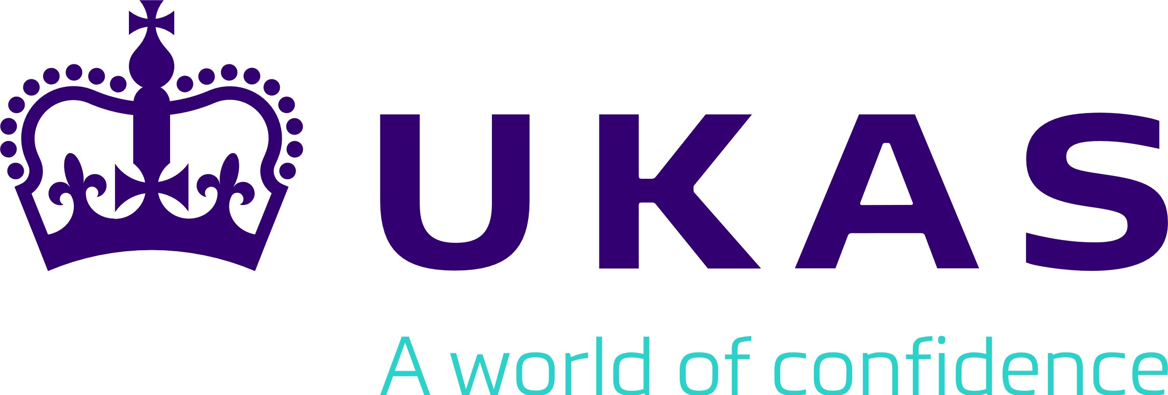
AGREEMENT FOR USE OF THE
IAF MLA MARK
BETWEEN A
LICENSED IAF MLA ACCREDITATION BODY MEMBER
AND AN
ACCREDITED CONFORMITY ASSESSMENT BODY (CAB)

1. The International Accreditation Forum Inc. (“IAF”) is the owner of the trademark known as the IAF Multilateral Recognition Arrangement Mark or IAF MLA Mark.
2. The United Kingdom Accreditation Service, the full post office address of whose principal office or place of business is 2 Pine Trees, Chertsey Lane, Staines-Upon-Thames, TW18 3HR, UK, has a nonexclusive and non-transferable license to use the IAF MLA Mark, subject to its maintenance of its IAF MLA Membership and IAF Accreditation Body (AB) membership and observance of conditions and restrictions set out in its agreement with the IAF MLA Member.
Note: The IAF Logo is not to be used by any IAF Member or accredited CAB on any documentation under any circumstances without permission. The IAF Logo is for use only by the IAF Board and Secretary to denote official IAF documents.
3. Enter accredited CAB’s full company name here, the full post office address of whose principal office or place of business is enter full business address here, applies for permission to use the IAF MLA Mark, only in conjunction with the licensed IAF MLA Member’s accreditation symbol, subject to the terms and conditions set out below.
4. The United Kingdom Accreditation Service grants to (accredited Conformity Assessment Body the “CAB”) permission to use the IAF MLA Mark for main scopes and sub scopes of the IAF MLA for which the CAB has been accredited by the (Licensed IAF MLA Member), from the date of this Agreement, subject to the conditions and restrictions as follows:
(a) The accredited CAB shall only use the IAF MLA Mark together with its accreditation body symbol in the manner set out in IAF ML 2 General Principles on Use of the IAF MLA Mark and in accordance with the main scopes and sub scopes of the IAF MLA of which the licensed IAF MLA Member is a Signatory, and for which the CAB has been accredited;
(b) The IAF MLA Mark shall be reproduced using an authorized copy obtained from the licensed IAF MLA Member and shall be reprinted according to the following specifications:
i) in black and white or in the colours Pantone 2747 (dark blue) and Pantone 299 (light blue),
ii) on a clearly contrasting background,
iii) in a size which makes all the words of the IAF MLA Mark clearly distinguishable, with the width of the IAF MLA Mark no less than 20 millimetres for printed media and 75 pixels for digital media.
(c) The proposed permitted use is non-exclusive;
(d) The permission granted to the accredited CAB to use the said IAF MLA Mark is non-transferable;
(e) The accredited CAB shall not use the IAF MLA Mark on any documentation unless the licensed IAF MLA Member’s accreditation symbol and the accredited CAB’s name or logo are included on the same displayed page and all are of approximately the same size;
Note: The documentation can be in any form or type of medium.
(f) The accredited CAB shall use the IAF MLA Mark in strict accordance with the instructions, conditions, standards of quality and IAF MLA Mark specifications supplied by the licensed IAF MLA Member or the IAF at any time and from time to time;
(g) The accredited CAB shall supply specimens of its usage of the IAF MLA Mark to the licensed IAF MLA Member or IAF, if requested by the licensed IAF MLA Member or IAF;
(h) The accredited CAB shall not allow its certified organisations to use the IAF MLA Mark;
(i) The accredited CAB shall monitor and take suitable action to control its use of the IAF MLA Mark and to prevent any incorrect references or misleading use by itself or its certified organizations;
(j) The accredited CAB acknowledges and agrees that it has no proprietary right, title or interest in the IAF MLA Mark;
(k) The accredited CAB agrees to co-operate fully and in good faith with the licensed IAF MLA Member and/or IAF for the purpose of securing or protecting IAF's right in the IAF MLA Mark;
(l) The accredited CAB further agrees not to challenge directly or indirectly IAF’s right, title or interest in the IAF MLA Mark.
5. The Agreement to use the IAF MLA Mark may be terminated as follows:
(a) at any time by agreement of the parties;
(b) at any time by the licensed IAF MLA Member in the event that the conditions in this Agreement are not satisfied;
(c) immediately in the event accreditation is withdrawn from the accredited CAB by the licensed IAF MLA Member;
(d) immediately in the event of the termination of the licensed IAF MLA Member’s membership of the IAF MLA or IAF membership;
(e) immediately in the event of the termination of the Agreement for the use of the IAF MLA Mark between IAF and the Licensed IAF MLA Member;
(f) by the licensed IAF MLA Member duly advising the accredited CAB; or
(g) by the IAF duly advising the accredited CAB.
6. The accredited CAB shall indemnify and save IAF, its directors, officers, employees and authorized representatives, including the licensed IAF MLA Member, from and against any and all claims, liabilities, demands, proceedings, causes of action, costs and expenses (including legal fees as incurred) arising from the breach or default of the accredited CAB under this agreement.
End of Agreement for Use of the IAF MLA Mark between a Licensed IAF MLA Member and an Accredited Conformity Assessment Body
Signed on behalf of enter name of accredited CAB here

Sign here
………………………………………………………………………………………
(Signature)
Name
(Name of signatory)
Title / position
(Title/position)
Date Select the date using the calendar

Signed on behalf of the United Kingdom Accreditation Service

Sign here
………………………………………………………………………………………
(Signature)

Name
(Name of signatory)

Title / Position
(Title/position)

Date Select date

Licensed to use the IAF MLA Mark in conjunction with the United Kingdom Accreditation Service’s accreditation symbol for the main scopes and sub scopes of the IAF MLA for which the CAB has been accredited by the United Kingdom Accreditation Service.

