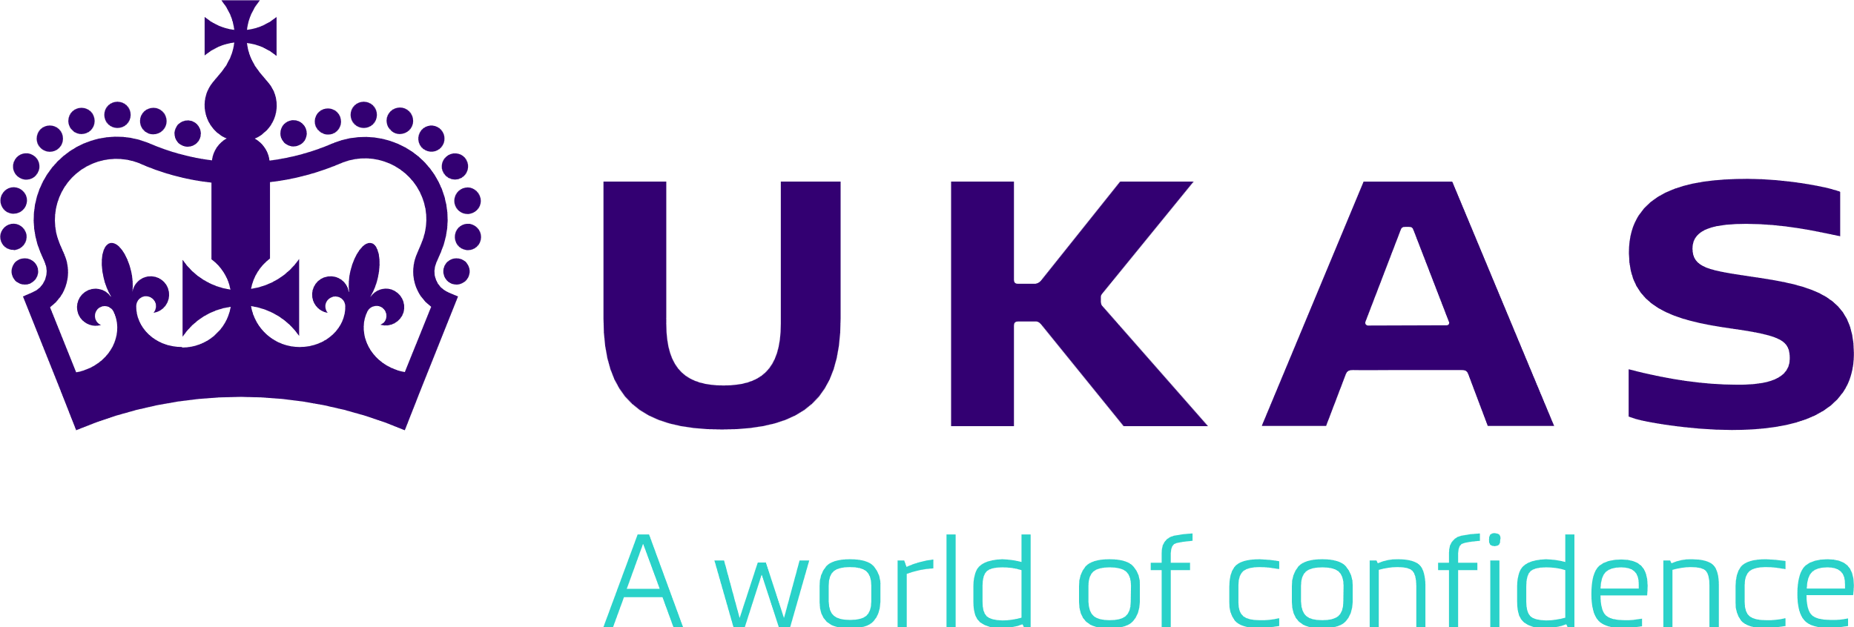

Notification Form for Change of Legal Entity

For all organisations seeking to transfer their UKAS accreditation to a new legal entity

Purpose
To provide UKAS with advance notification of the intent to transfer accreditation from one legal entity to another.
If you are not in a position to complete this form in full and/or there are aspects of the changes which are commercially confidential, please call your UKAS Assessment Manager to discuss.
Note: If you are an existing accredited organisation that is intending to change its name or if there has been a change of ownership where the legal entity is unaffected there is no requirement to complete this form. In these instances, please notify your appointed UKAS Assessment Manager in writing (email is acceptable) at the earliest opportunity detailing the change. Depending on the changes, a new UKAS Agreement may need to be signed. For more guidance, please visit the UKAS website https://www.ukas.com/customer-area/change-of-ownership-name-legal-entity/.

Summary of UKAS Policy on the Change of Legal Entity & Transfer of Accreditation
- Notification of the intent to transfer accreditation from one legal entity to another must be provided to UKAS before any changes to the legal entity take place to avoid accreditation being suspended or withdrawn. The notification and request for transfer of accreditation shall be formally submitted to UKAS using this form. Upon receipt of this form, UKAS will undertake a review to determine how the change in legal entity may impact on the maintenance of accreditation and whether accreditation can be transferred.
- Where the change in legal entity does not impact on the accredited service provided (e.g. where the management, resources, management system and procedures remain unchanged) then transfer of accreditation may be relatively straightforward. However, if it is evident from the information provided that the accredited service could or will be affected by the change then UKAS shall determine whether any additional assessment effort will be required to determine conformity with the requirements for accreditation.
- If the change in legal entity also requires additional activities to be added to the accredited scope then this will be dealt with separately - see UKAS website www.ukas.com ‘Customer Area/Extending or Amending Accreditation’.
- Work undertaken by the new legal entity cannot be reported as accredited until the transfer of accreditation process is complete, and accreditation granted. UKAS will require information to be provided to support the transfer of accreditation (see section 4). If this information is not supplied this will result in a delay in processing the transfer.
- The legal entity to which accreditation is being transferred must be prepared to accept all contractual, legal, financial and other obligations which relate to the accredited activities of the current accredited entity for accreditation to be transferred (see Annex 1 Declaration). This includes obligations to UKAS, accreditation scheme owners, competent authorities and customers to whom the current legal entity provides accreditation services. Where this is not possible the accreditation cannot be transferred and the new legal entity will need to submit a new application for accreditation - see UKAS website (www.ukas.com) ‘Accreditation/How to Apply for Accreditation’.
- Return of Form
Once this form has been completed, the declaration signed and any supporting information has been attached (as indicated in the form), please return to the following address:
Applications Unit
United Kingdom Accreditation Service
2 Pine Trees, Chertsey Lane, Staines-upon-Thames, TW18 3HR
Email to: applications@ukas.com
- Cost
UKAS will charge a minimum of 0.5 day effort to cover the cost of transferring accreditation to the new legal entity. Additional cost may be incurred if further assessment is required to review the request for transfer (see 2 above). A quotation for any additional assessment effort will be provided in advance and the fees invoiced after review and/or assessment is completed.
All information given to UKAS for the purposes of this application will be treated in the strictest confidence.

Part 1: About the Change
Please answer the following questions:
  - Please state the reason behind the change of legal entity

  - When is the change of legal entity expected to take place?

Part 2: Company Information
  - Name of existing legal entity

Please enter the name of the company currently holding the UKAS accreditation
Accreditation ref no(s): |  | Company registration no: (if applicable)

  - Main Contact person for the transfer
Tel: | Fax:
E-mail:

  - Contact details of person signing the UKAS Customer Agreement*
Name:
Position:
E-mail:
*The person signing the UKAS Customer Agreement on behalf of your company/organisation will need to be of director level (or equivalent). This authorised person shall be sent an electronic copy of the Agreement for signing digitally. The transfer of accreditation to the new legal entity cannot be completed until UKAS has received an appropriately signed copy of the UKAS Customer Agreement.

  - Name of new legal entity

Please enter the name of the company applying for the transfer of UKAS Accreditation from the company named in 2.1.
Company registration no: (if applicable)

Note: If the company registration number is not yet available, please indicate when it is expected to be available and supplied to UKAS?

Please state legal status of company (tick one of the following options and provide documentary evidence of this status)
☐ | Limited Company (Ltd) | ☐ | Partnership
☐ | Limited Liability Partnership (LLP) | ☐ | Academic institution
☐ | Charity | ☐ | Public limited company (plc)
☐ | Sole trader | ☐ | Other:
☐ | Joint venture | ☐ | Public Body

Main Address
 |  | Postcode:
Web address: www.
Tel: | Fax:
E-mail:

  - Invoicing contact name and address (if different from address stated above)
Postcode:

  - Offices expected to be covered by the accreditation(s)

  - Is your company part of a group or corporation? ☐ YES (go to 2.8) ☐ NO (go to 2.9)

  - Group/corporation name
Address:
Postcode:

Please state your company’s relationship with the organisation given above (e.g. parent, holding company, etc.):

  - Please identify any parties with which the new legal entity has a relationship, and which could pose a risk to impartiality. Such a relationship could be based on ownership, governance, management, personnel, shared resource, finances, contracts, marketing (including branding), although such relationships do not necessarily present a risk to impartiality.
Note: if this is not known at this time please state this but please be aware UKAS will require this information as part of the review process.
Related Body | Key activities undertaken which could pose a risk to impartiality and nature of relationship

(If a risk to impartiality is identified, the body shall be able to demonstrate to UKAS how it eliminates or minimises such risk to an acceptable level).

  - Are you registered as an Approved Body, or does your accreditation include recognised sector schemes?
☐ YES ☐ NO
If the answer to the above is ‘Yes’ then please state below the name of the Regulation or Scheme, the name of the authoritative body, and confirm the date when they were informed of this change in legal entity.
Relevant Regulation or Sector Scheme | Authoritative Body | Date Informed

Part 3: Information on Proposed Changes
Note: if the extent of the proposed changes is not known at this time please state this noting UKAS will need to ensure this is reviewed during the transfer process.

  - Resources
    - Key Positions: Please state any proposed changes to key positions within the management system because of the change in legal entity, e.g. Technical Manager, Quality Manager, qualified staff required by accreditation, etc. (and deputies)

    - Workforce: Please state any expected impact that the change in legal entity will have on the current workforce, e.g. loss of authorised staff, recruitment of new staff, transfer of staff between sites/sections, etc.

    - Premises: Please state any expected changes to premises undertaking the accredited activities because of the change in legal entity, e.g. changes to laboratories, workshops, areas for sample receipt/storage/disposal, record storage, etc.

    - Equipment: Please state any expected changes to key equipment because of the change in legal entity, e.g. loss, new purchases, re-commissioning if relocated, changes to maintenance and/or calibration contracts, etc.

  - Management System
    - Management System: Please state any proposed changes to the management system that underpins the existing accredited scope, and which has been subject to previous UKAS assessments, because of the change in legal entity.

    - Accredited Methods/Procedures: Please state any proposed changes to the existing accredited methods/procedures because of the change in legal entity.

NB: Any significant changes identified will be reviewed by UKAS to determine the impact this will have on those activities previously accredited. This may lead to the need to undertake additional assessment, either by document review, remote assessment, site visit or a combination of these before transfer of UKAS accreditation can be granted.

Part 4: Supporting Information

In support of this notification I enclose the following evidence:

☐ | Evidence that the new legal entity will accept all liabilities resulting from the accredited activities of the existing accredited body
☐ | Quality Manual (or equivalent management system documentation)
☐ | Certificate of Incorporation or Articles of Association (if appropriate) or evidence to confirm the legal status of the new entity
☐ | Evidence of suitable insurance/liability cover

I acknowledge that UKAS will charge a minimum of 0.5 day effort to cover the cost of transferring accreditation to the new legal entity. This shall be invoiced separately.
Documents or information which is not currently available should not prevent the submission of this notification/application. However, please note UKAS will not be able to finalise and grant your transfer of accreditation until all required evidence and items to support the transfer have been provided and reviewed.

I declare that I am authorised, on behalf of the company/organisation, to submit this notification and that the information contained herein is both correct and accurate to the best of my knowledge and belief.

Signed: |  | Date: | Click or tap to enter a date.
Print name: |  | Position:

ANNEX 1 DECLARATION
The following declaration needs to be signed prior to the finalisation of the Transfer of Accreditation.
If at the point of notification, the legal entity to which accreditation is being transferred is not fully incorporated and therefore not immediately able to accept all contractual, legal, financial and other obligations which relate to the accredited activities of the current legal entity then this declaration can be submitted later. However, it must be completed and returned to UKAS before the transfer of accreditation can be finalised.
This declaration needs to be completed by the company/organisation seeking the transfer of accreditation from the stated company/organisation that currently holds the existing accreditation(s) from UKAS.

The company/organisation agrees to comply with the relevant European or International Standards, the applicable UKAS requirements, and UKAS Publications as listed on the website (www.ukas.com) and to adapt to any changes in the requirements.

In making this declaration I confirm the following:

      - The new legal entity accepts all contractual, legal, financial and other obligations which relate to the accredited activities of the existing accredited body

      - The new legal entity agrees to accept all outstanding debts owed to UKAS by the existing accredited body (Note: UKAS will not grant transfer of accreditation until all such debts are settled in full)

      - The new legal entity agrees to accept responsibility for any complaints that UKAS investigates with respect to the existing accredited body

      - The existing accredited body is not under investigation or threat of prosecution because of legal action taken against its accredited services

      - Where applicable, i.e. where required within the standard used for accreditation or within UKAS guidance publications, plans have been drawn up to ensure the new legal entity holds the required level of liability cover with respect to the accredited services to be offered

I declare that I am authorised, on behalf of the company/organisation, to submit this declaration and that the information contained herein is both correct and accurate to the best of my knowledge and belief.

Signed: |  | Date: | Click or tap to enter a date.
Print name: |  | Position:

